SQL exercise 1
Q1)
WITH RankedProducts AS
(
SELECT
ProductName,
Category,
Price,

ROW_NUMBER() OVER (
PARTITION BY Category
ORDER BY Price DESC
) AS RowNumber,

RANK() OVER (
PARTITION BY Category
ORDER BY Price DESC
) AS RankNumber,

DENSE_RANK() OVER (
PARTITION BY Category
ORDER BY Price DESC
) AS DenseRankNumber

FROM Products
)

SELECT *
FROM RankedProducts
WHERE RowNumber <= 3
ORDER BY Category, Price DESC;

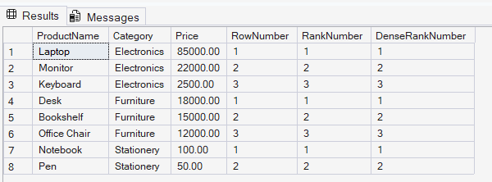

Q2)
Grouping sets
SELECT
c.Region,
p.Category,
SUM(od.Quantity) AS TotalQuantity
FROM Customers c
JOIN Orders o
ON c.CustomerID = o.CustomerID
JOIN OrderDetails od
ON o.OrderID = od.OrderID
JOIN Products p
ON od.ProductID = p.ProductID
GROUP BY GROUPING SETS
(
(c.Region, p.Category),
(c.Region),
(p.Category)
)
ORDER BY Region, Category;
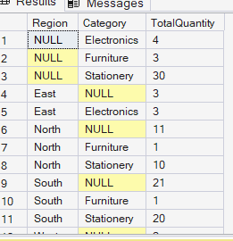
Roll Up
PRINT '===== ROLLUP =====';

SELECT
c.Region,
p.Category,
SUM(od.Quantity) AS TotalQuantity
FROM Customers c
JOIN Orders o
ON c.CustomerID = o.CustomerID
JOIN OrderDetails od
ON o.OrderID = od.OrderID
JOIN Products p
ON od.ProductID = p.ProductID
GROUP BY ROLLUP
(
c.Region,
p.Category
)
ORDER BY Region, Category;
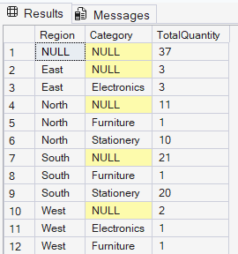
Cube
SELECT
c.Region,
p.Category,
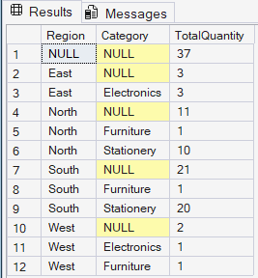
SUM(od.Quantity) AS TotalQuantity
FROM Customers c
JOIN Orders o
ON c.CustomerID = o.CustomerID
JOIN OrderDetails od
ON o.OrderID = od.OrderID
JOIN Products p
ON od.ProductID = p.ProductID
GROUP BY CUBE
(
c.Region,
p.Category
)
ORDER BY Region, Category;

3)
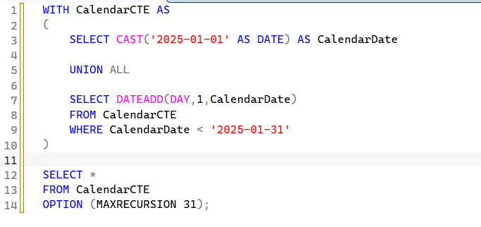

MERGE Products AS Target
USING StagingProducts AS Source

ON Target.ProductID = Source.ProductID

WHEN MATCHED THEN
UPDATE SET
Target.Price = Source.Price

WHEN NOT MATCHED THEN
INSERT
(
ProductID,
ProductName,
Category,
Price
)
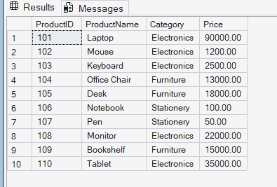
VALUES
(
Source.ProductID,
Source.ProductName,
Source.Category,
Source.Price
);

SELECT *
FROM Products
ORDER BY ProductID;

4)
PIVOT UNPIVOT
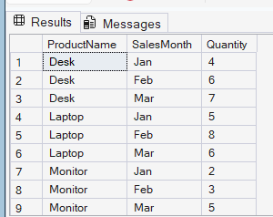
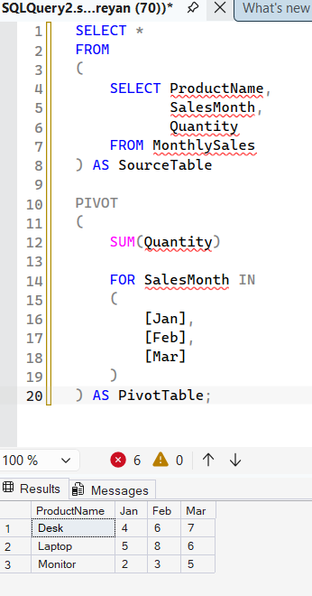
SELECT
ProductName,
SalesMonth,
Quantity
FROM
(
SELECT ProductName,
Jan,
Feb,
Mar
FROM
(
SELECT ProductName,
SalesMonth,
Quantity
FROM MonthlySales
) S

PIVOT
(
SUM(Quantity)
FOR SalesMonth IN ([Jan],[Feb],[Mar])
) P
) T

UNPIVOT
(
Quantity
FOR SalesMonth IN
(
Jan,
Feb,
Mar
)
) U;

5)
